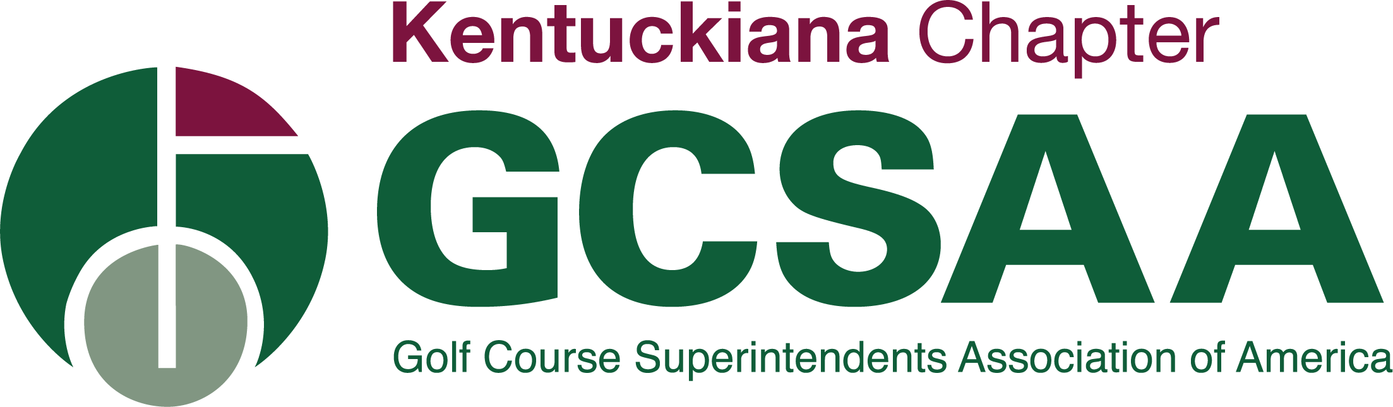

GCSAA Conference and Trade Show Scholarship

For Superintendents, Assistant Superintendents & Equipment Managers

San Diego, CA | February 3 – 6, 2025 | San Diego Convention Center

Deadline to submit Application September 30, 2024

Eligibility Requirements
- Must be a KGCSA member in good standing with the designation of ABC or EM
If you have any questions, please email: lisab@kgcsa.info

Contact Information
Name:______________________________________________________________________________
Job Title:____________________________________________________________________________
Home Address:_______________________________________________________________________
City, State/Province, Zip: _____________________________ Country:__________________________
Home phone: __________________________________ Cell phone:____________________________
Email address: _______________________________________________________________________
GCSAA Member #:_____________________________ Membership Classification:________________
Employer Information
Company:___________________________________________________________________________
Facility Address:______________________________________________________________________
City, State, Zip:__________________________________________ Country:_____________________

Interest in Participation, Leadership Opportunities and Financial Need
Please indicate the last year attended or note if never: __________________________________

Answer the following questions in 250 words or less

- Please provide the reason(s) why you have been unable to attend the GCSAA Education Conference and Golf Industry Show in the last five years or have never attended.
- Other than assisting with the advancement of your professional status as a GCSAA member, what do you hope to gain from attending the Golf Industry Show?
- What continuing education, beyond college or a technical degree, have you taken on a local, regional or national basis to assist in advancing your career goals?
- After this experience, how do you intend to be more involved in GCSAA and your local chapter?

- In your opinion, what is the biggest challenge or opportunity facing the golf course management profession and your suggestion in which to address it?
- List any other information you may wish to make available to be considered in the selection process, which could include financial need, community involvement, and honors received both personally and professionally.
Participation Agreement
KGCSA scholarship winner is required to attend the Golf Industry Show sponsored by the Golf Course Superintendents Association of America. The monies distributed by the KGCSA Board of Directors are to solely help offset the expenses for attending. If the winner is not able to attend for any reason, they will forfeit the scholarship money.

If selected, I can devote the required time to attend the conference. Yes____ No_____

_______________________________________________________
Applicant’s Signature

All applications are to be submitted via email no later than September 30, 2024
lisab@kgcsa.info

